Prateek Gupta

gupta198@purdue.edu

ECE 661 Homework 4

**Theory Question**

What is the theoretical reason for why the LoG of an image can be computed as a DoG. Also explain in your own words why computing the LoG of an image as a DoG is computationally much more efficient for the same value of σ.

The Laplacian of Gaussian takes derivatives on blurred images. By doing this, the edges and corners can be found. However, computing derivatives of blurred images is expensive. This process can be estimated by simply taking the difference of two blurred images. This still allows for the similar features to be found but saves on finding the derivative of each image.

**Overview of Task**

In previous reports we constructed homographies by manually selecting corresponding points on images using GIMP. This time, we will attempt to automate the selection of interest points using Harris corner detection and SIFT.

**Harris Corner Detection**

A corner is defined as any pixel having varied gray levels in multiple directions. We will start by finding the corners on each image in a pair. In order to do this, we will convert the image into grayscale, so we can detect the changing gray values. Now, we will need to construct a Haar filter. This is done based on the scale σ we want to use. We will take the scale, multiply it by 4, then round up to the nearest even number. This will allow us to construct the filters for estimating the x-derivative dx and the y-derivative dy. Below is an example for σ = 1.2:

$$4σ=4\left(1.2\right)=4.8$$

$$filter size=6$$

This means our Dx and Dy will be 6x6 (Note that Dx and Dy will be the filters to help estimate dx and dy). The filters will be constructed in the following manner:

$$D_{x}=\left[\begin{matrix}-1 & -1 & -1 & 1 & 1 & 1 \\ -1 & -1 & -1 & 1 & 1 & 1 \\ -1 & -1 & -1 & 1 & 1 & 1 \\ -1 & -1 & -1 & 1 & 1 & 1 \\ -1 & -1 & -1 & 1 & 1 & 1 \\ -1 & -1 & -1 & 1 & 1 & 1\end{matrix}\right]$$

$$D_{y}=\left[\begin{matrix}-1 & -1 & -1 & -1 & -1 & -1 \\ -1 & -1 & -1 & -1 & -1 & -1 \\ -1 & -1 & -1 & -1 & -1 & -1 \\ 1 & 1 & 1 & 1 & 1 & 1 \\ 1 & 1 & 1 & 1 & 1 & 1 \\ 1 & 1 & 1 & 1 & 1 & 1\end{matrix}\right]$$

We now need to apply each of these filters to an area around each pixel. This area is determined by multiplying σ by 5 and rounding up to the nearest odd number. So, in our case, we would convolve each filter to a 7x7 area around each pixel. We will let the result of the convolution be denoted as dx and dy respectively. We will then use this result to construct a matrix C. This will help us determine if that pixel is a corner.

$$C= \left[\begin{matrix}\sum{d_{x}^{2}} & \sum{d_{x}d_{y}} \\ \sum{d_{x}d_{y}} & \sum{d_{y}^{2}}\end{matrix}\right]$$

Now, we will compute the Harris response. This will tell us whether the pixel is a corner or not.

$$R=det⁡(C)-0.05{\left(trace\left(C\right)\right)}^{2}$$

Where:

$$\det\left(C\right)= \sum{d_{x}^{2}}\sum{d_{y}^{2}}-{\left(\sum{d_{x}d_{y}}\right)}^{2}$$

$$trace\left(C\right)=\sum{d_{x}^{2}+\sum{d_{y}^{2}}}$$

We apply this to every pixel in the gray image and use this to construct a list of corners.

**Interest Point Detection**

After running through the corner detection algorithm, we have a list of corners on each image in a pair. We now need to establish a correspondence between those corners and determine if they are interest points. Again, we will utilize the grayscale images for this. We compare the corners on each image, and if they exceed a certain threshold value, their correspondence can be confirmed. There are two techniques for this, the Sum of Squared Differences (SSD) and the Normalized Cross Correlation (NCC). They are explained by the equations below.

$$SSD=\sum_{i}{\sum_{j}{{\left|f_{1}\left(i, j\right)-f_{2}\left(i,j\right)\right|}^{2}}}$$

$$NCC= \frac{\sum{\sum{(f_{1}\left(i,j\right)-m_{1})(f_{2}\left(i,j\right)-m_{2})}}}{\sqrt{\left[\sum{\sum{{\left(f_{1}\left(i,j\right)-m_{1}\right)}^{2}}}\right]\left[\sum{\sum{{\left(f_{2}\left(i,j\right)-m_{2}\right)}^{2}}} \right]}}$$

The following pages contains the results of each of these two methods for 5 pairs of images with four different scales each.

**Original Images:**

Pair 1



Pair 2

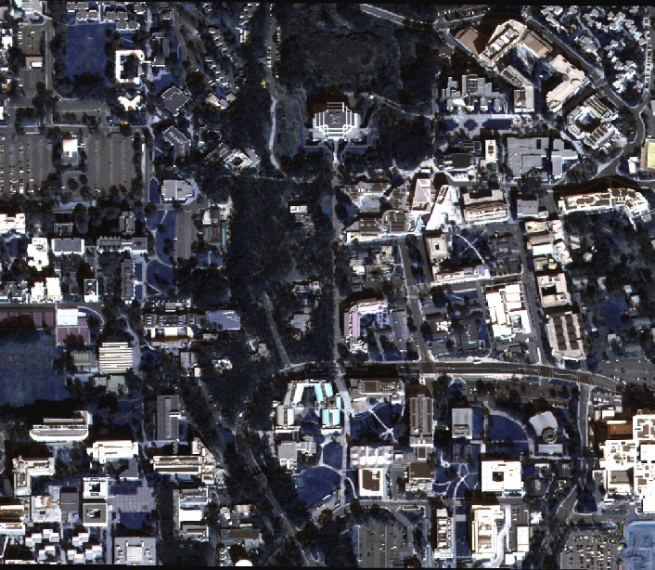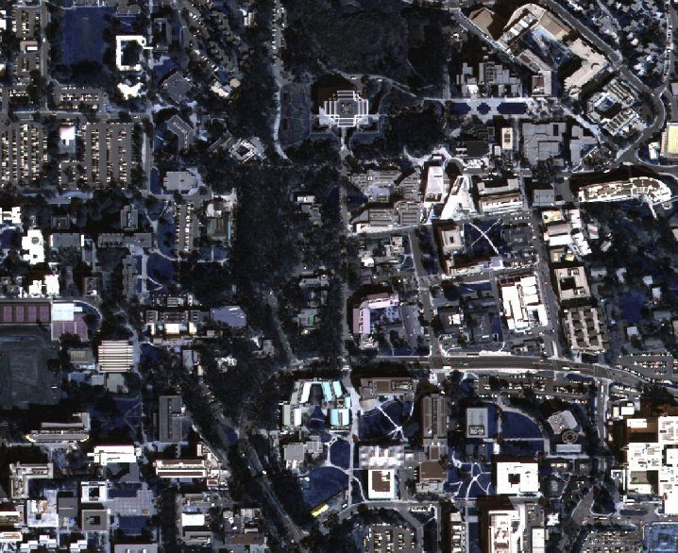

Pair 3

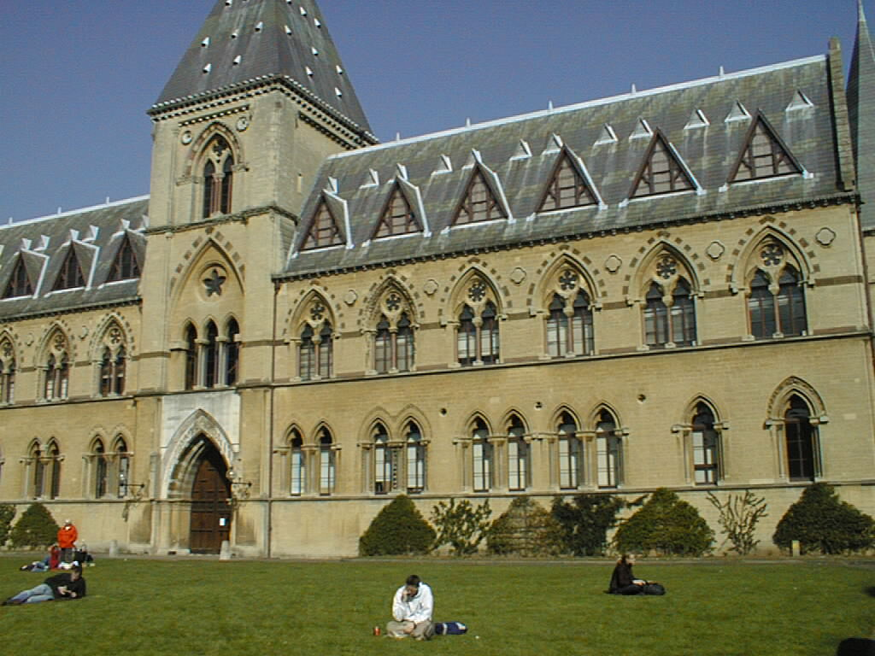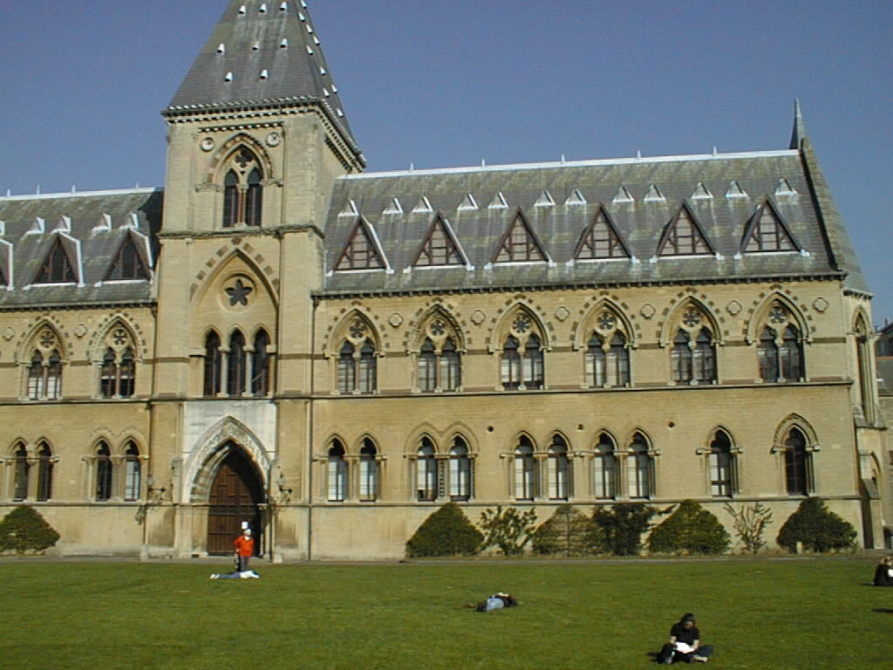

Pair 4

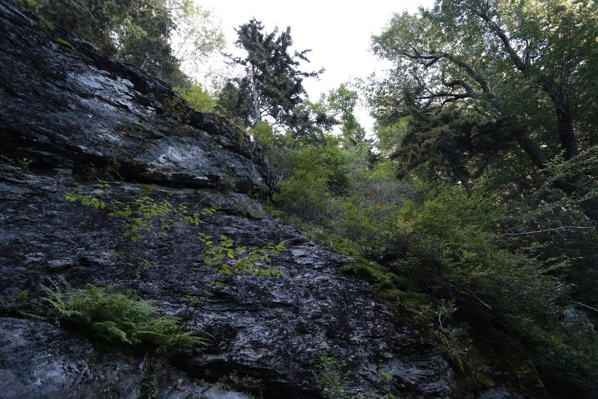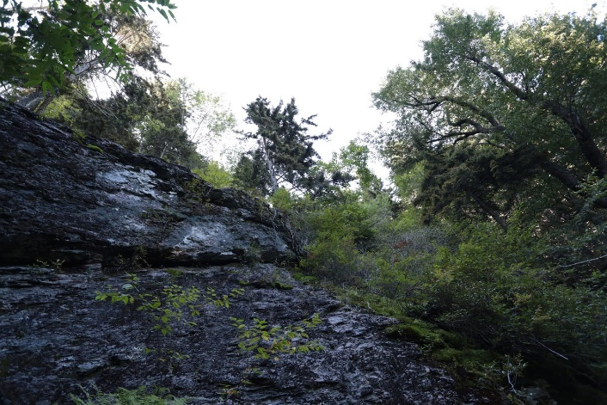

Pair 5

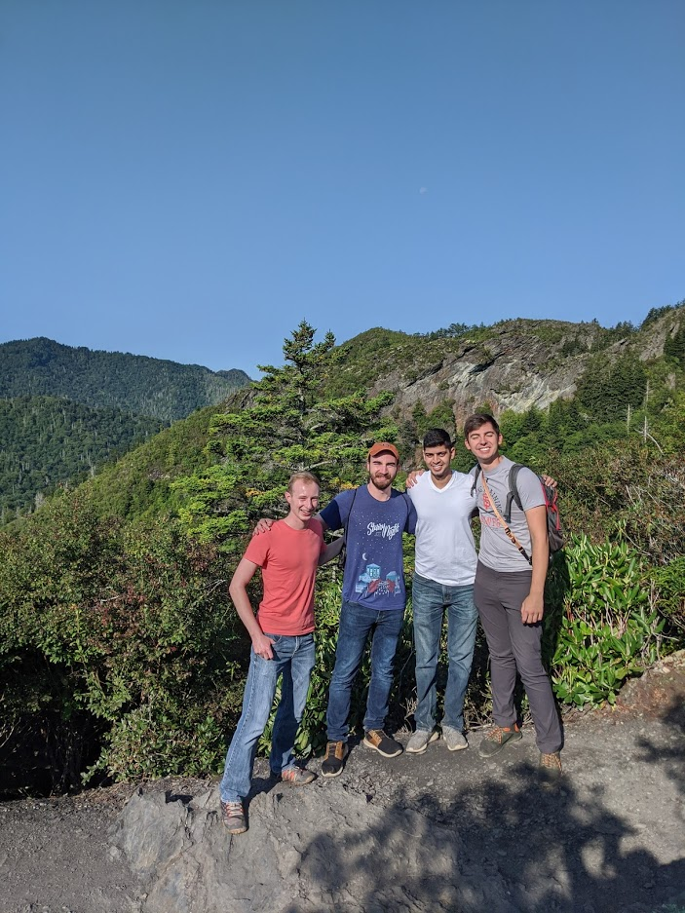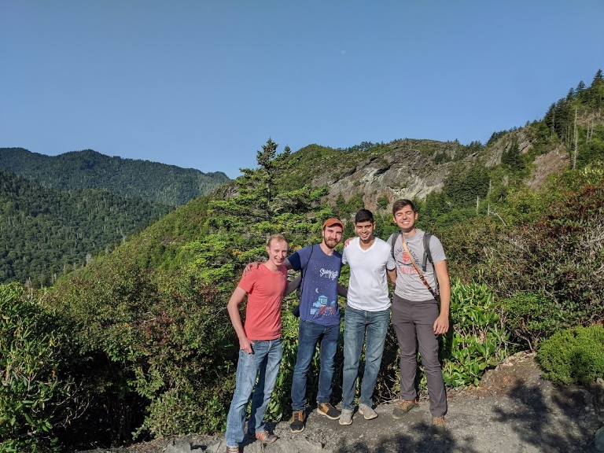

**Results:**

Pair 1, σ = 0.7, SSD

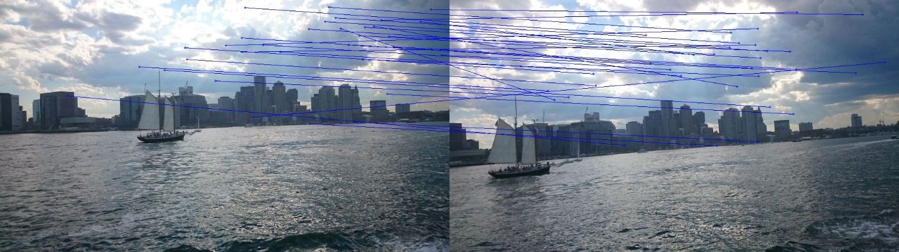

Pair 1, σ = 0.7, NCC

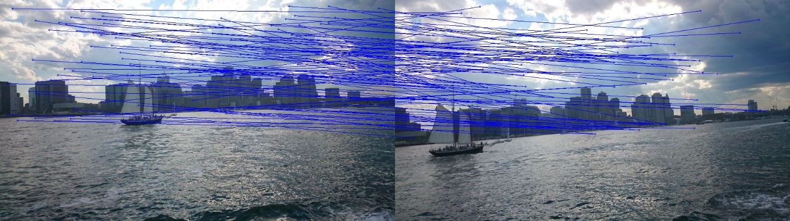

Pair 1, σ = 1.0, SSD



Pair 1, σ = 1.0, NCC



Pair 1, σ = 1.2, SSD

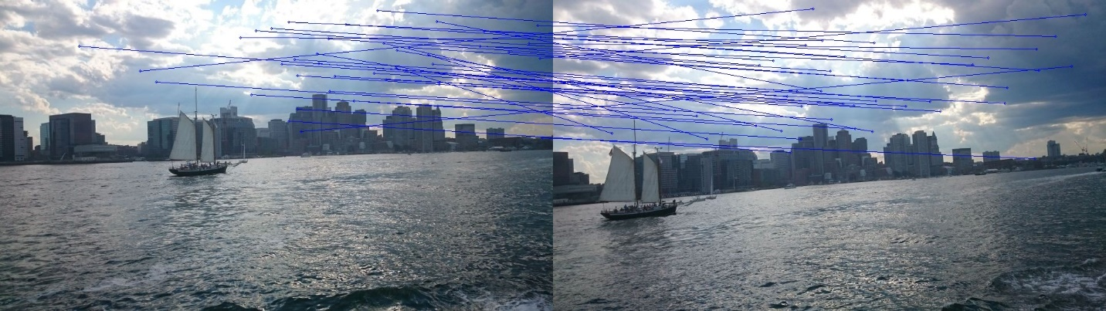

Pair 1, σ = 1.2, NCC

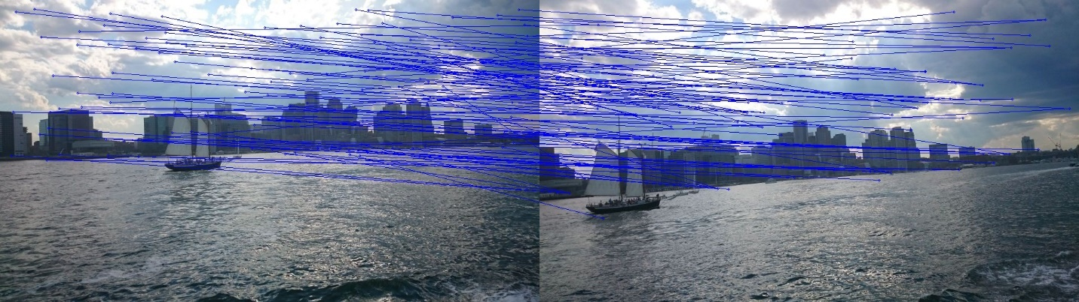

Pair 1, σ = 2.0, SSD

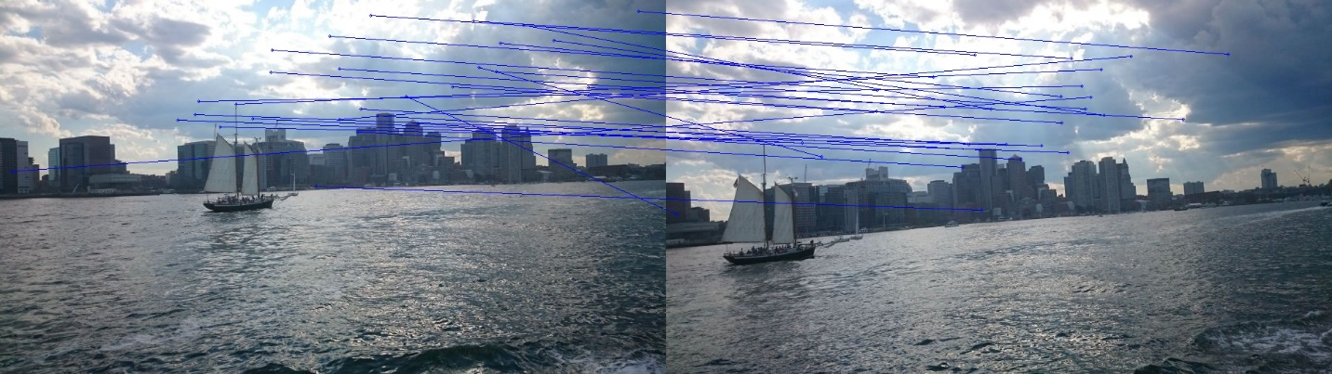

Pair 1, σ = 2.0, NCC

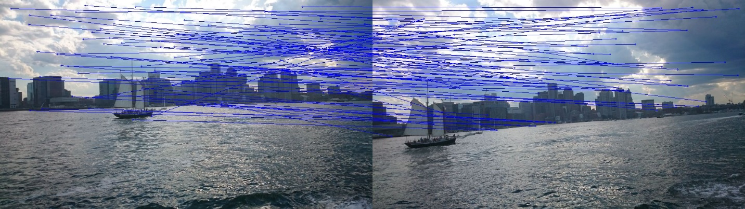

Pair 2, σ = 0.7, SSD

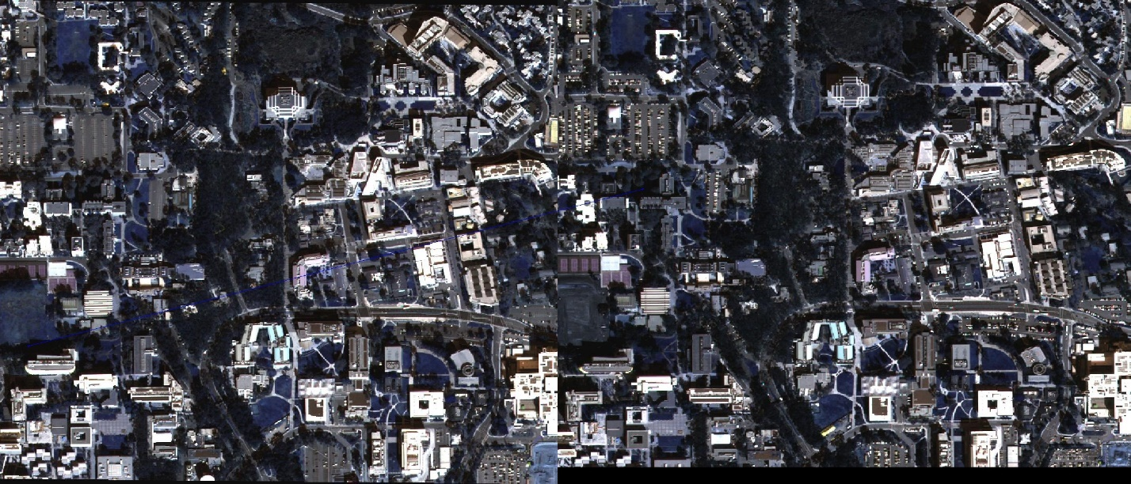

Pair 2, σ = 0.7, NCC

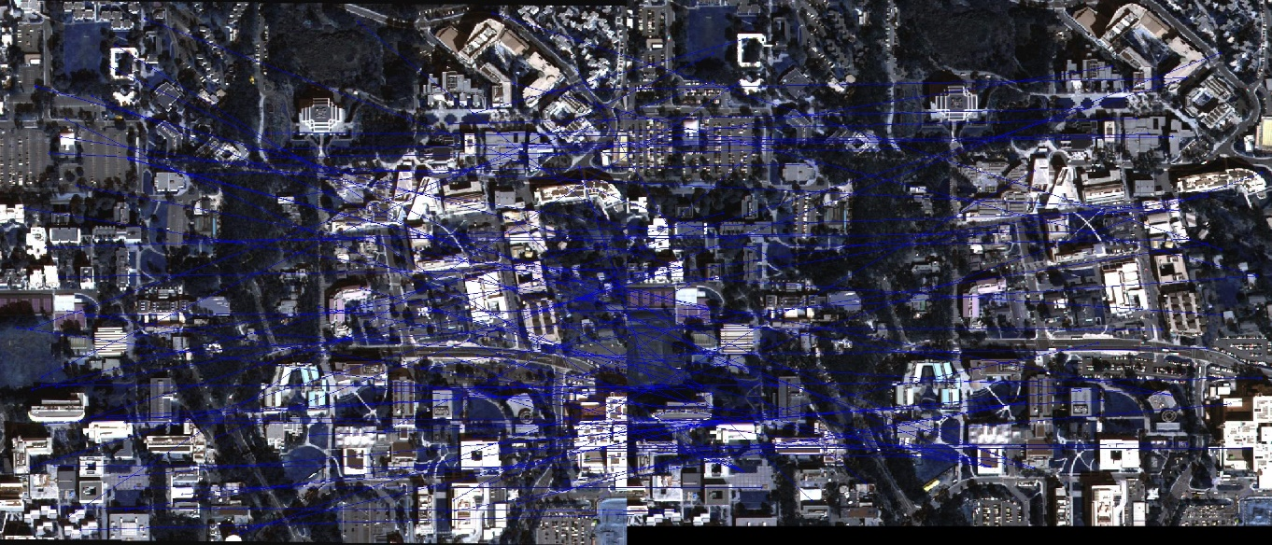

Pair 2, σ = 1.0, SSD

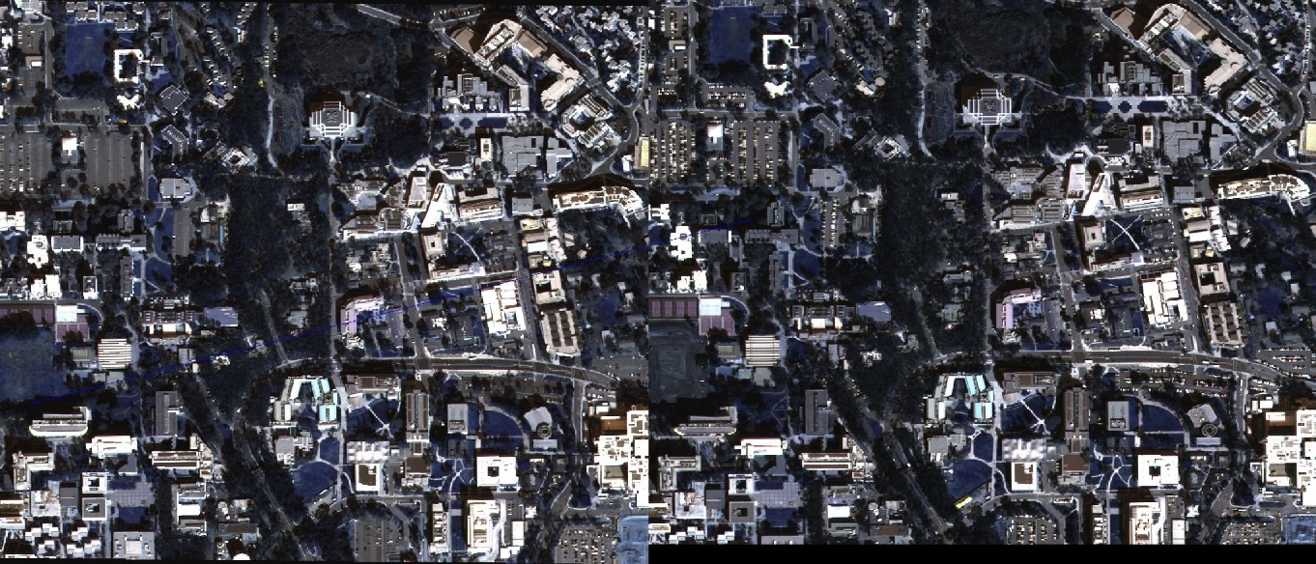

Pair 2, σ = 1.0, NCC

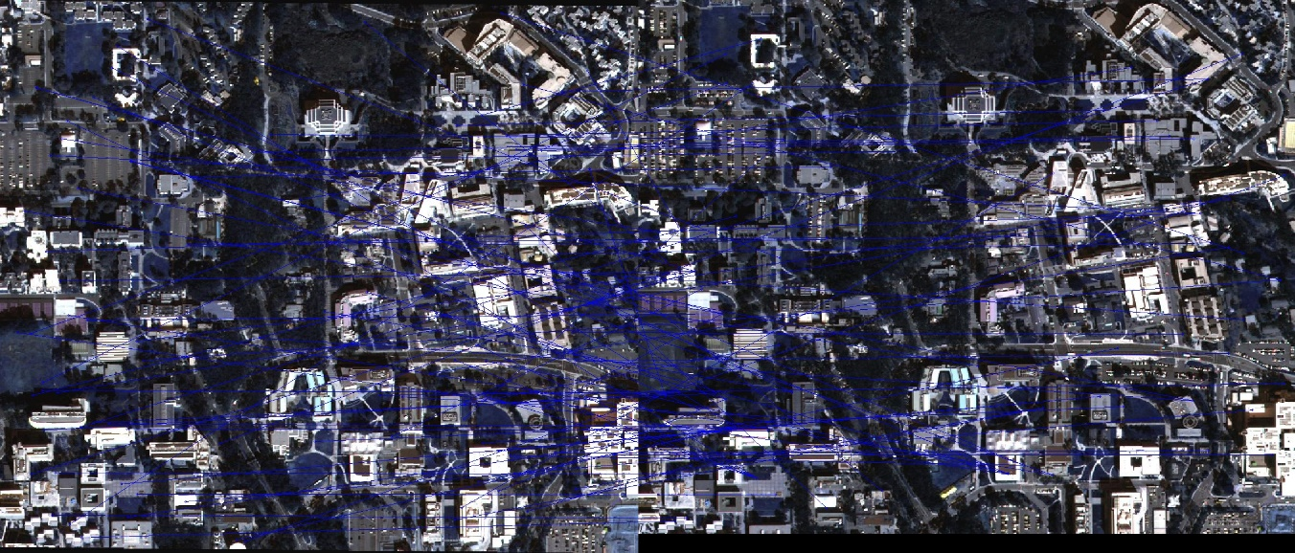

Pair 2, σ = 1.2, SSD

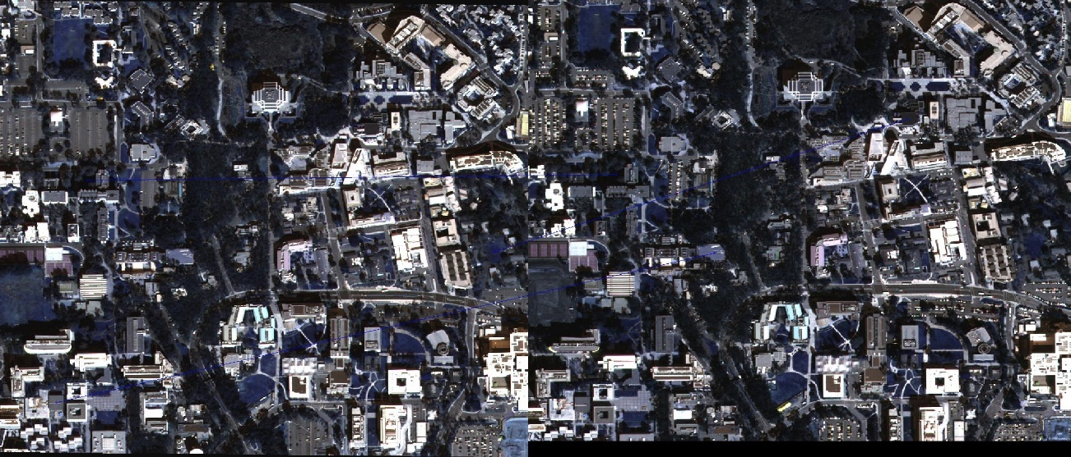

Pair 2, σ = 1.2, NCC

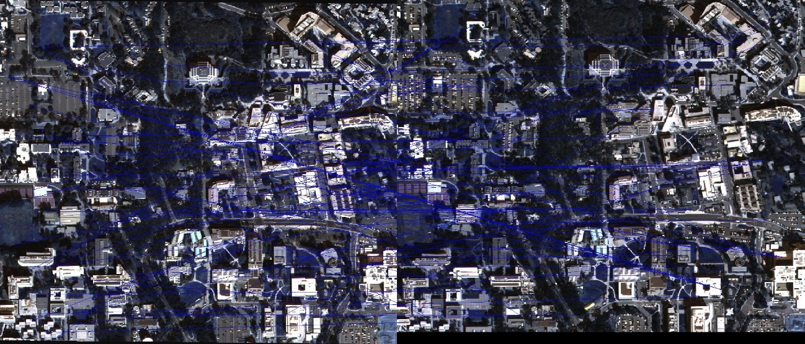

Pair 2, σ = 2.0, SSD

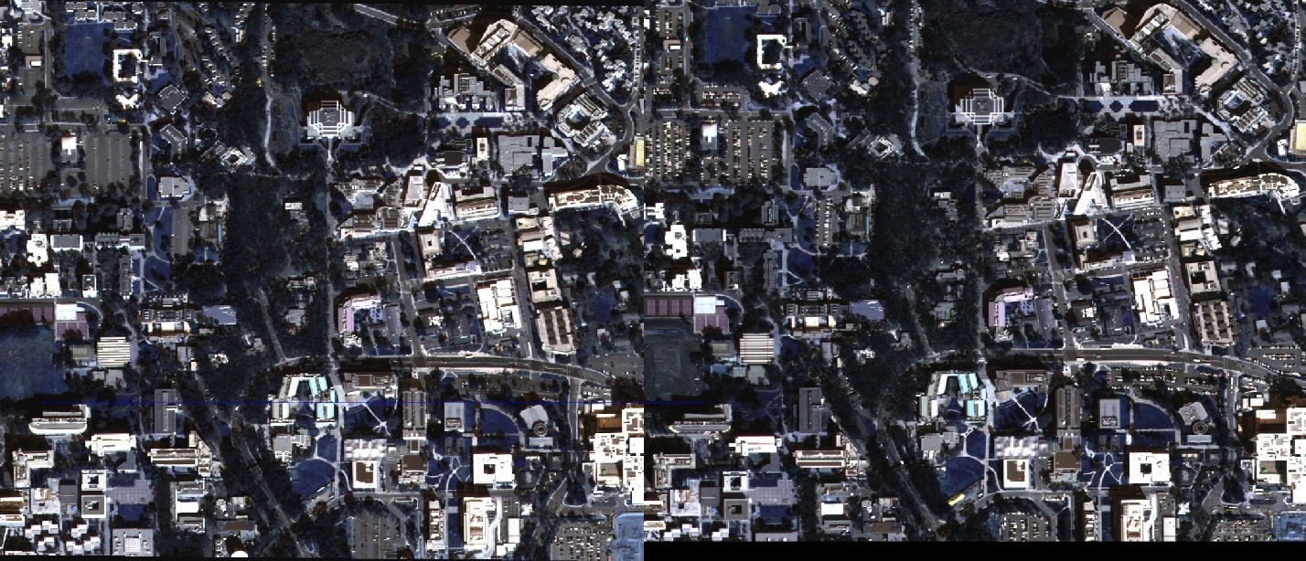

Pair 2, σ = 2.0, NCC

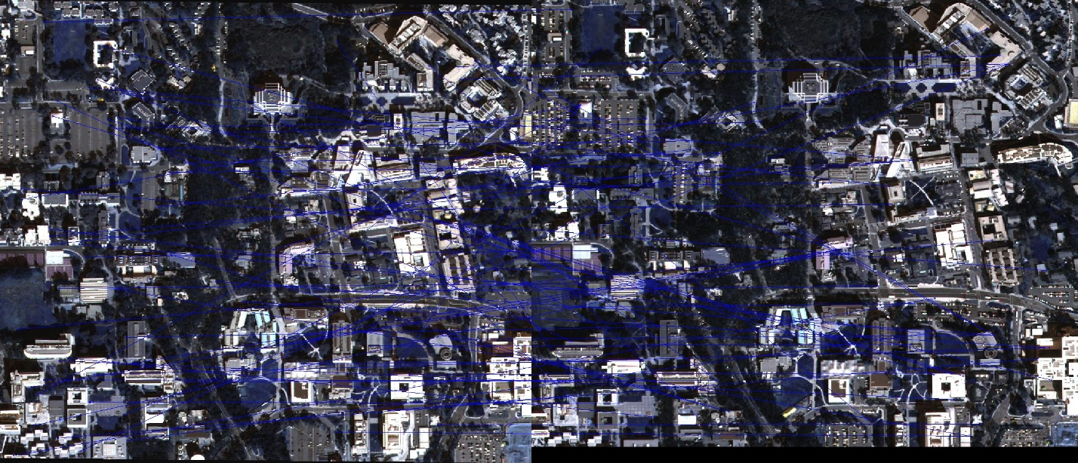

Pair 3, σ = 0.7, SSD

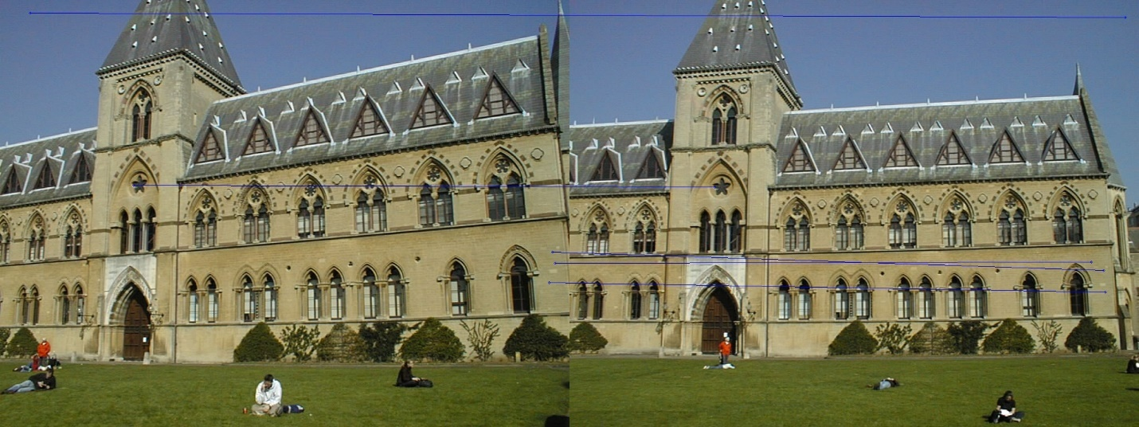

Pair 3, σ = 0.7, NCC

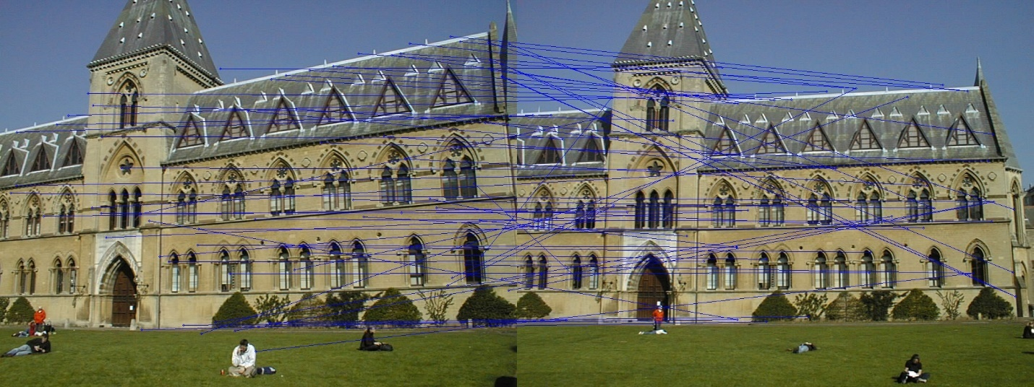

Pair 3, σ = 1.0, SSD



Pair 3, σ = 1.0, NCC



Pair 3, σ = 1.2, SSD

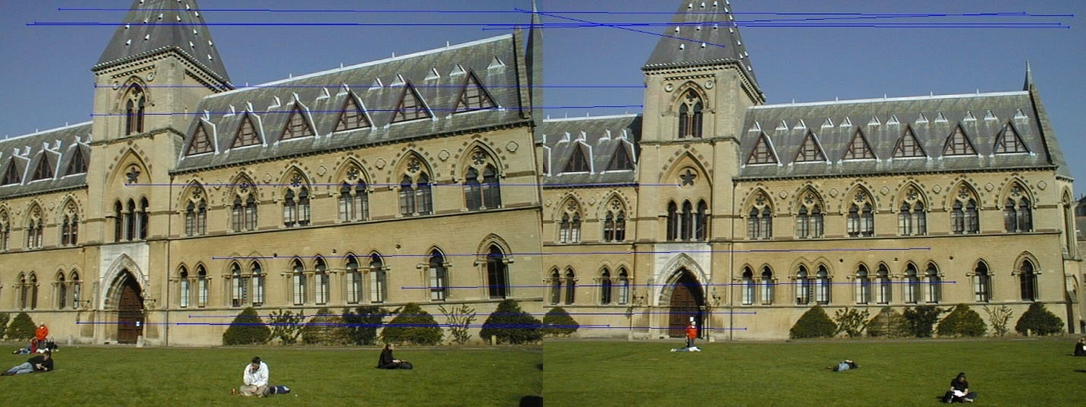

Pair 3, σ = 1.2, NCC



Pair 3, σ = 2.0, SSD

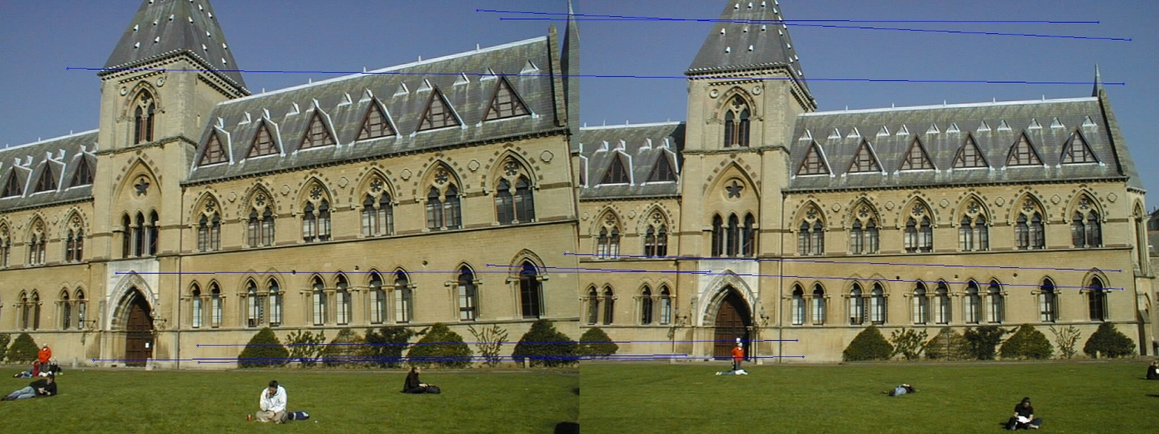

Pair 3, σ = 2.0, NCC

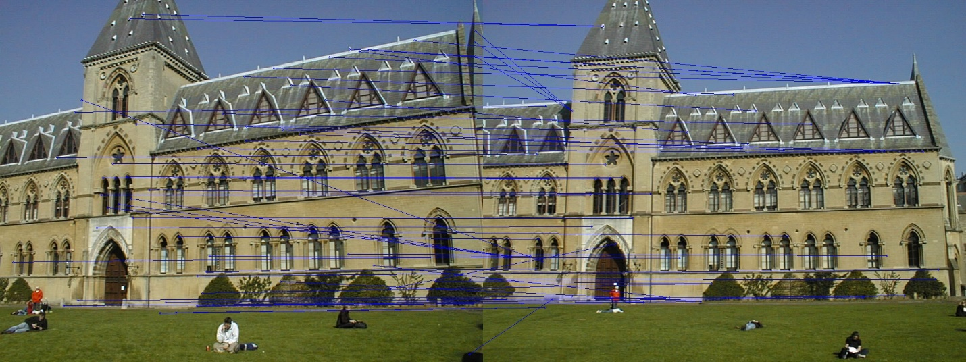

Pair 4, σ = 0.7, SSD

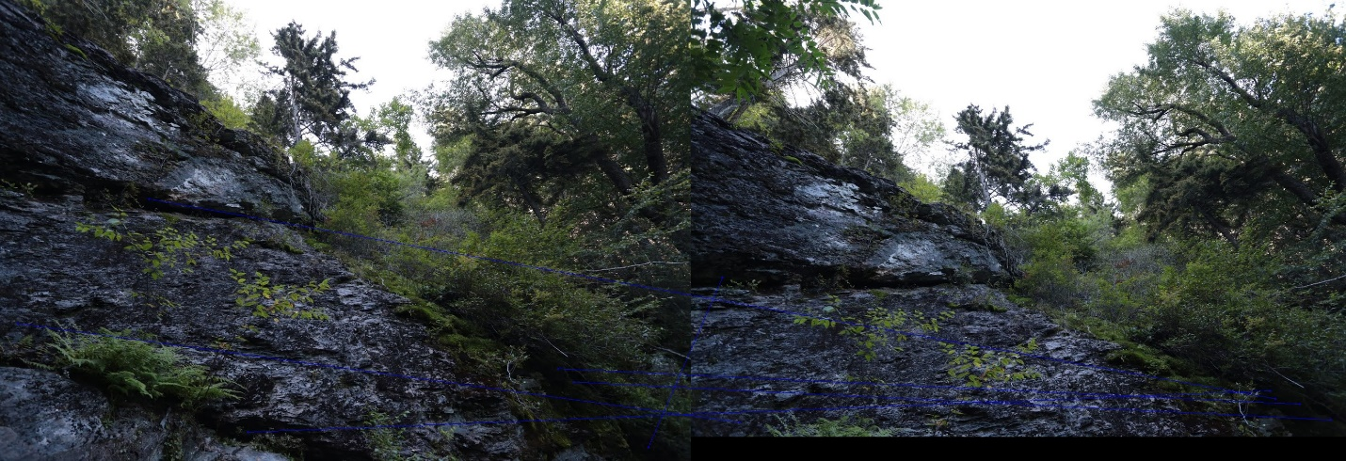

Pair 4, σ = 0.7, NCC

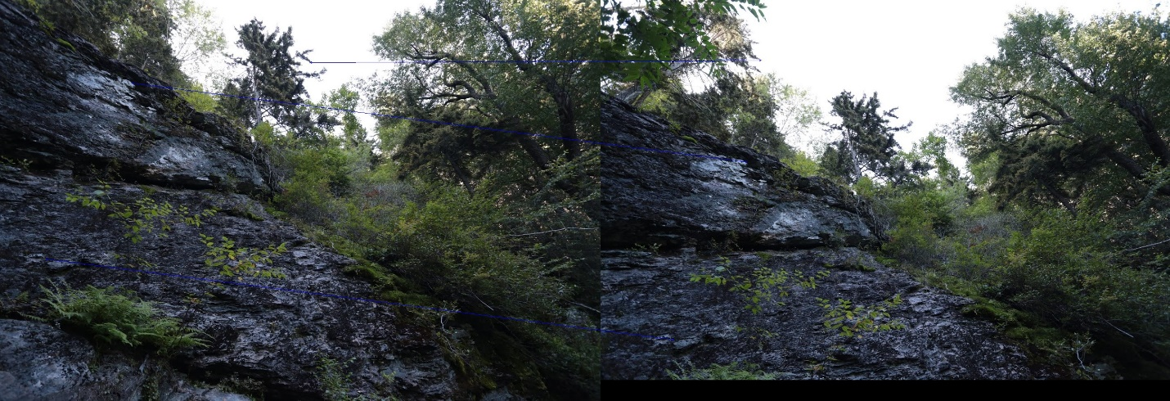

Pair 4, σ = 1.0, SSD



Pair 4, σ = 1.0, NCC



Pair 4, σ = 1.2, SSD

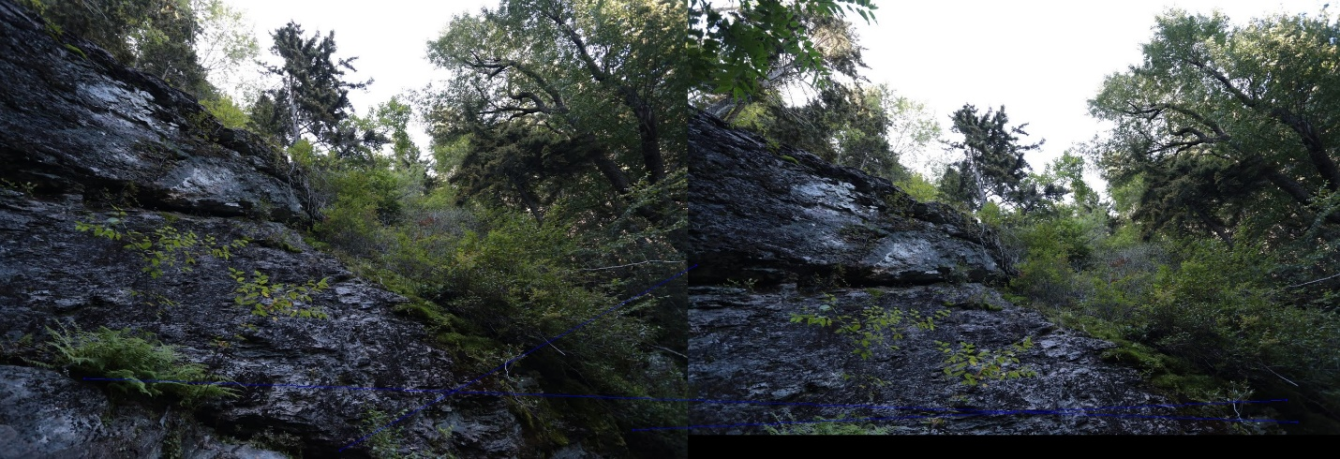

Pair 4, σ = 1.2, NCC

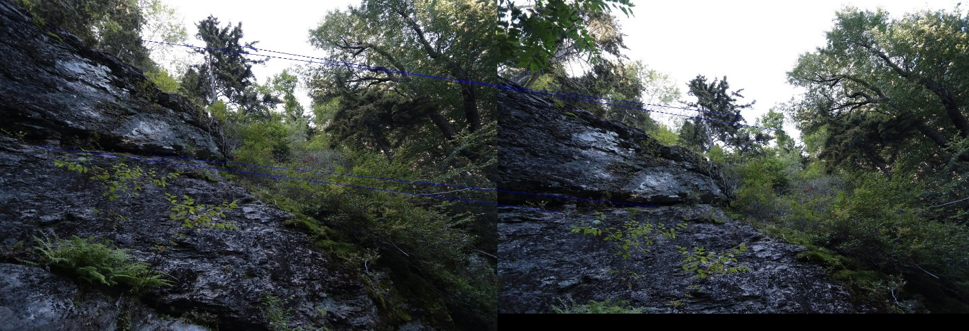

Pair 4, σ = 2.0, SSD

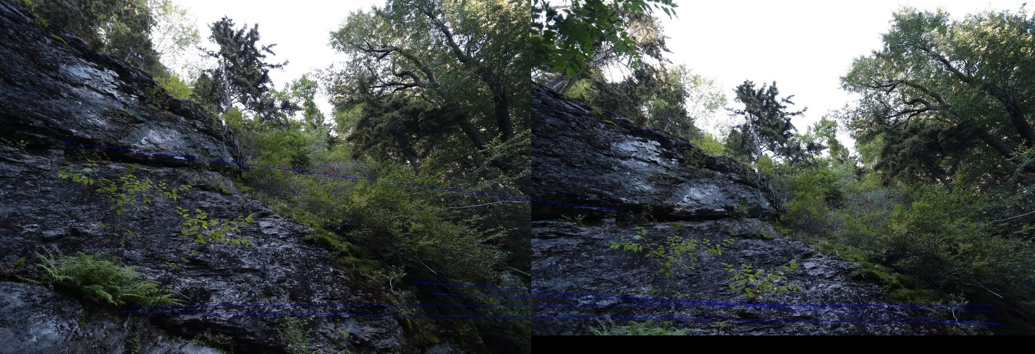

Pair 4, σ = 2.0, NCC

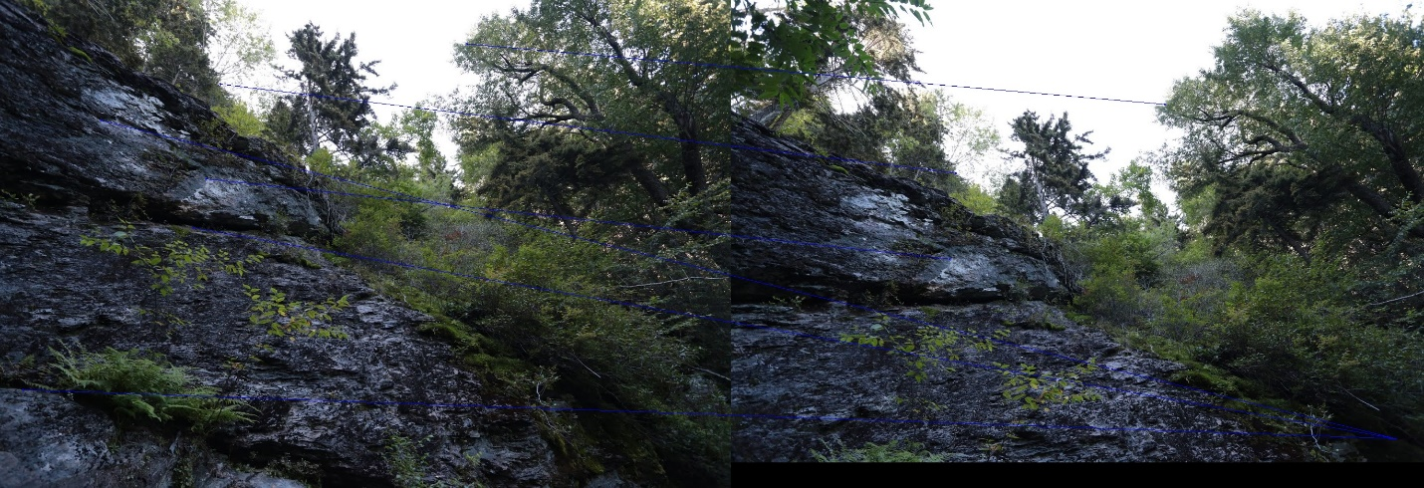

Pair 5, σ = 0.7, SSD

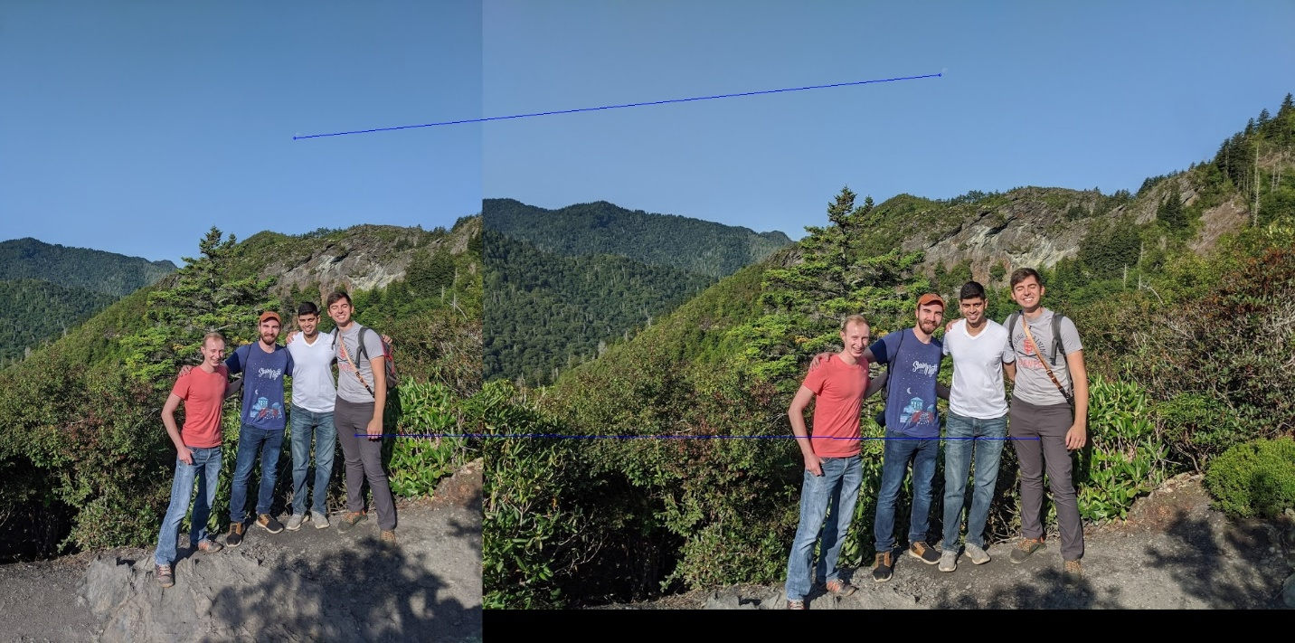

Pair 5, σ = 0.7, NCC

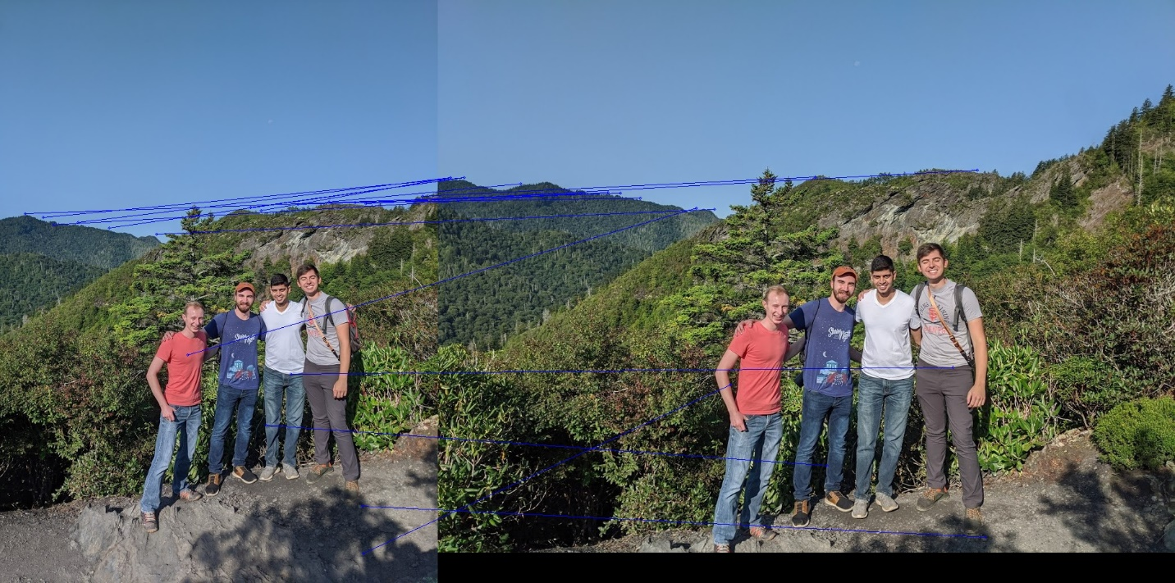

Pair 5, σ = 1.0, SSD



Pair 5, σ = 1.0, NCC



Pair 5, σ = 1.2, SSD

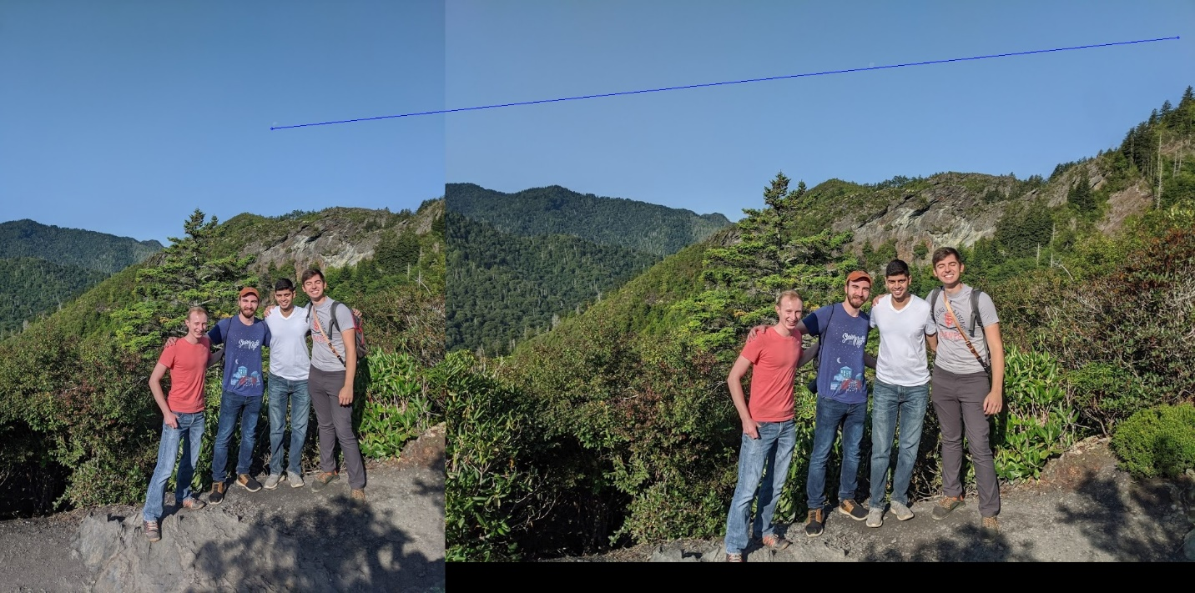

Pair 5, σ = 1.2, NCC

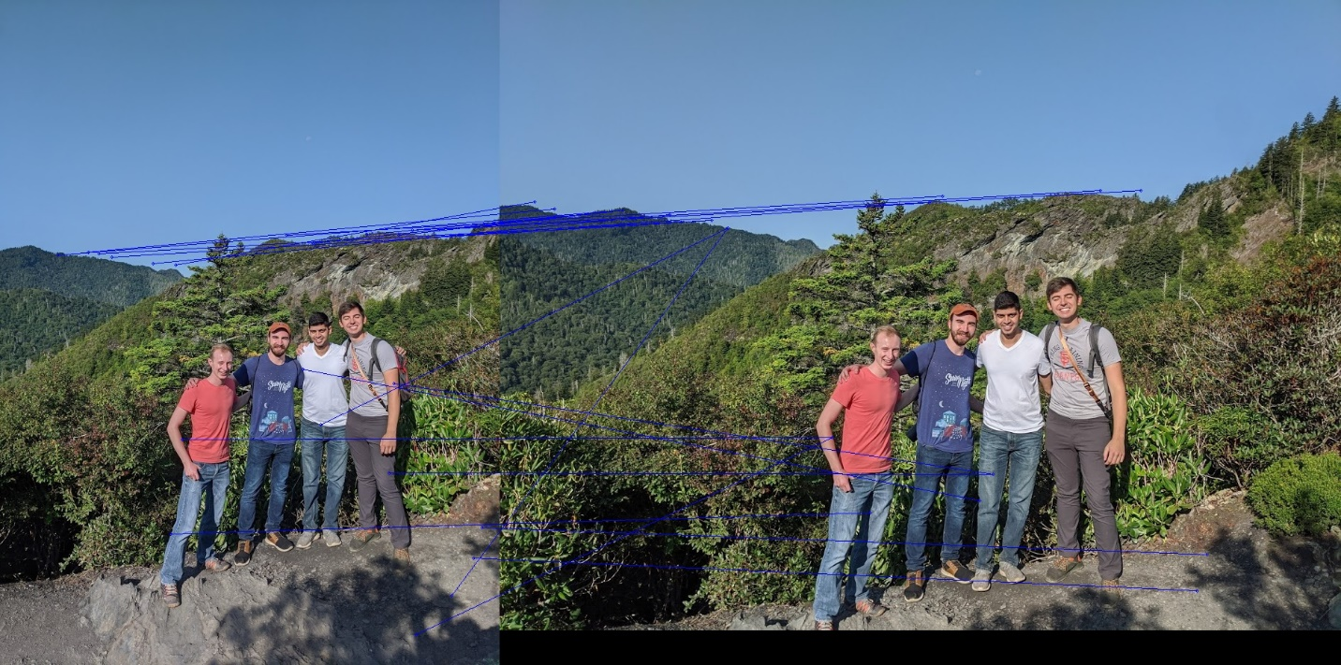

Pair 5, σ = 2.0, SSD

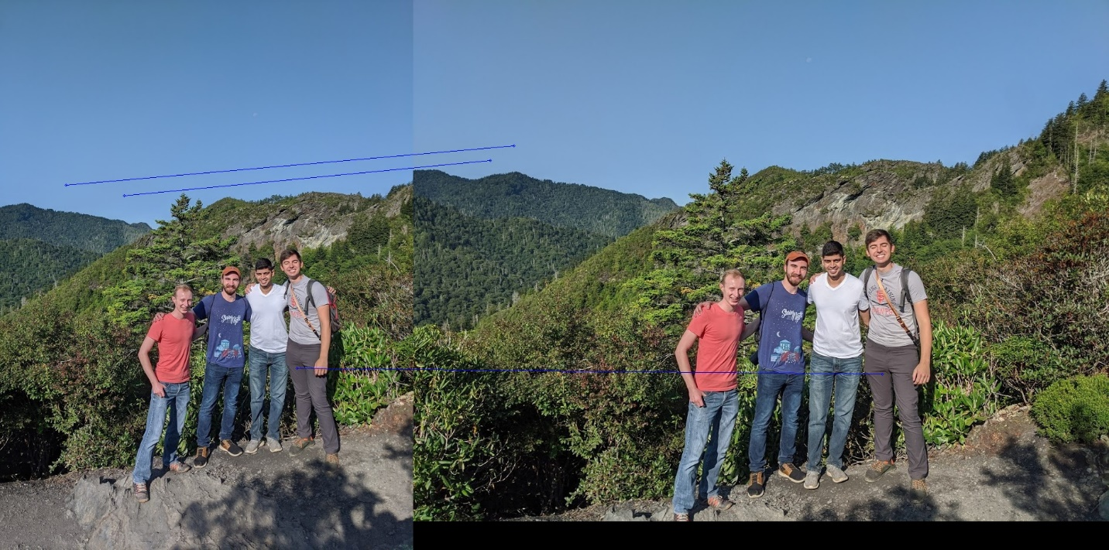

Pair 5, σ = 2.0, NCC

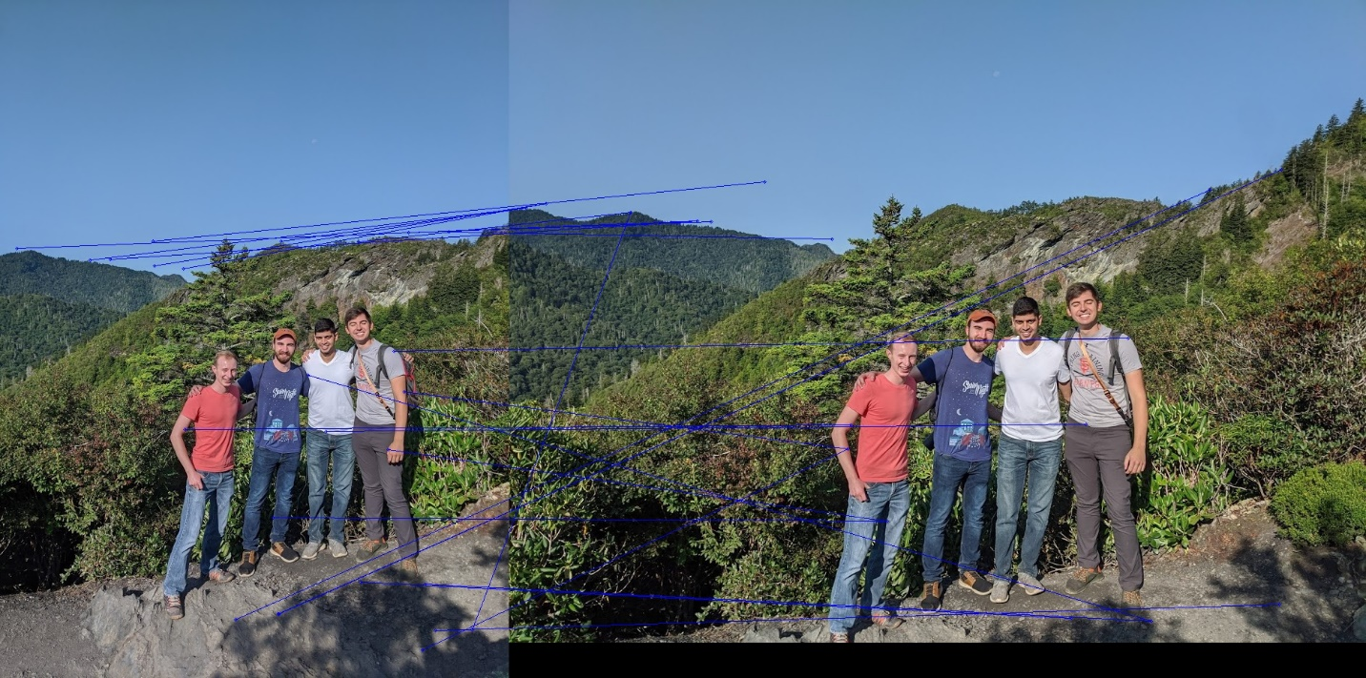

**SIFT**

Scale Invariant Feature Transform (SIFT) approximates the Laplacian of Gaussian (LoG) by using the Difference of Gaussian (DoG) to find interest points. We start by constructing a DoG pyramid, that is, we blur the image over and over. We find the differences in those images to estimate the local extrema over the 3x3 region of each pixel. Depending on the scaling value we use, this region expands on the original image. In other words, as σ increases (meaning going from lower to higher octaves), the output of the DoG finds more and more coarse corners. Below are the results of finding the interest points using SIFT.

Pair 1, SIFT

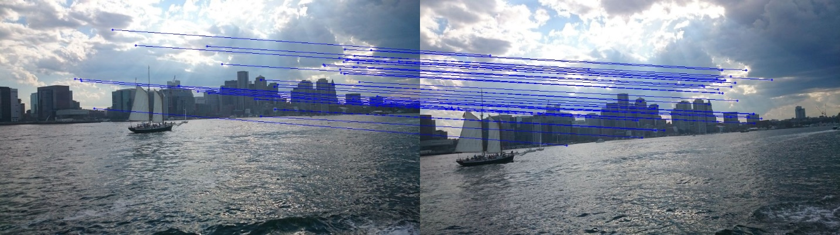

Pair 2, SIFT



Pair 3, SIFT

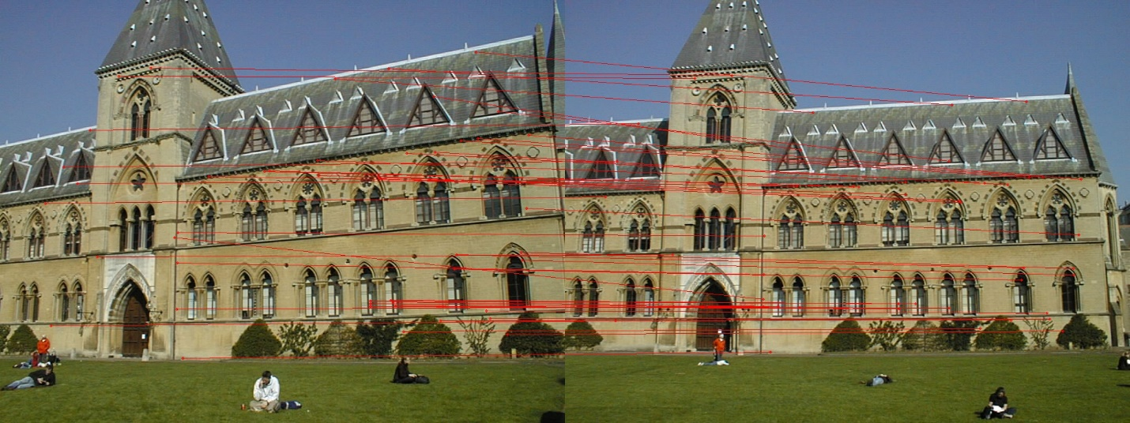

**Comments**

The Harris point detection does a reasonable job of finding the correspondences, but it is not entirely accurate. It seems to do a better job with higher σ. NCC also seems to do a better job of finding the corners that correspond to each other than SSD. After applying SIFT, it is evident that this is superior. It is significantly faster and gives much cleaner results.

import numpy as np

import cv2

def harrisCorners(im, sigma):

dim = np.ceil(sigma * 4)

if dim % 2 != 0:

dim+=1

oneMat = np.ones((int(dim/2), int(dim/2)), dtype=int)

negMat = -1 * oneMat

D_x = np.hstack((negMat, oneMat))

D_x = np.vstack((D_x, D_x))

D_y = np.vstack((oneMat, negMat))

D_y = np.hstack((D_y, D_y))

dx = cv2.filter2D(im, -1, D_x)

dy = cv2.filter2D(im, -1, D_y)

C_size = int(np.ceil(sigma * 5))

if (C_size % 2 == 0):

C_size+=1

C_size_half = int(C_size / 2)

threshold = np.zeros(im.shape)

for i in range(im.shape[0] - C_size):

for j in range(im.shape[1] - C_size):

dx_kernal = dx[i:i+C_size, j:j+C_size]

dy_kernal = dy[i:i+C_size, j:j+C_size]

dx2 = np.sum(np.square(dx_kernal))

dy2 = np.sum(np.square(dy_kernal))

dxdy = np.sum(np.multiply(dx_kernal, dy_kernal))

C_det = np.subtract(np.multiply(dx2, dy2), np.square(dxdy))

C_tr = np.add(dx2, dy2)

threshold[i + C_size_half, j + C_size_half] = C_det - 0.05 * np.square(C_tr)

thresh_size = 29

thresh_size_half = int(thresh_size / 2)

thresholdAvg = np.mean(abs(threshold))

corners=[]

for i in range(im.shape[0]-thresh_size):

for j in range(im.shape[1]-thresh_size):

if threshold[i+thresh_size_half,j+thresh_size_half] > 0 and abs(threshold[i+thresh_size_half,j+thresh_size_half]) > thresholdAvg:

thresh = threshold[i:i+thresh_size,j:j+thresh_size]

if threshold[i+thresh_size_half,j+thresh_size_half] == np.max(thresh):

corners.append([i+thresh_size_half,j+thresh_size_half])

return np.array(corners)

def SSD(im1, im2, cnr1, cnr2):

SSD = np.zeros((len(cnr1), len(cnr2)))

for i in range(len(cnr1)):

for j in range(len(cnr2)):

f1 = im1[cnr1[i, 0] - 12 : cnr1[i, 0] + 13, cnr1[i, 1] - 12 : cnr1[i, 1] + 13]

f2 = im2[cnr2[j, 0] - 12 : cnr2[j, 0] + 13, cnr2[j, 1] - 12 : cnr2[j, 1] + 13]

SSD[i, j] = np.sum(np.square(np.subtract(f1, f2)))

thresh = np.mean(SSD) * 4.5

pts = []

for i in range(len(cnr1)):

for j in range(len(cnr2)):

if SSD[i, j] == np.min(SSD[i,:]) and SSD[i,j] < thresh:

min_local_value = SSD[i,j]

SSD[i,j] = np.max(SSD[i,:])

else:

continue

if min_local_value / np.min(SSD[i,:]) < 0.7:

SSD[:,j] = np.max(SSD)

SSD[i,j] = min_local_value

pts.append([cnr1[i],cnr2[j]])

return np.array(pts)

def NCC(im1, im2, cnr1, cnr2):

NCC = np.zeros((len(cnr1), len(cnr2)))

for i in range(len(cnr1)):

for j in range(len(cnr2)):

f1 = im1[cnr1[i, 0] - 12 : cnr1[i, 0] + 13, cnr1[i, 1] - 12 : cnr1[i, 1] + 13]

f2 = im2[cnr2[j, 0] - 12 : cnr2[j, 0] + 13, cnr2[j, 1] - 12 : cnr2[j, 1] + 13]

ncc = np.sum(np.multiply(np.subtract(f1, np.mean(f1)), np.subtract(f2, np.mean(f2))))

ncc /= np.sqrt(np.sum(np.square(np.subtract(f1, np.mean(f1)))) * np.sum(np.square(np.subtract(f2, np.mean(f2)))))

NCC[i, j] = ncc

pts=[]

for i in range(len(cnr1)):

for j in range(len(cnr2)):

if NCC[i,j]==np.max(NCC[i,:]) and NCC[i,j]>0.8:

pts.append([[cnr1[i,0],cnr1[i,1]],[cnr2[j,0],cnr2[j,1]]])

return np.array(pts)

def showPoints(im1, im2, corners):

im = np.zeros((max(im1.shape[0], im2.shape[0]), im1.shape[1] + im2.shape[1],3))

im[0 : im1.shape[0], 0 : im1.shape[1]] = im1

im[0 : im2.shape[0], im1.shape[1] : im1.shape[1] + im2.shape[1]] = im2

for cnr in corners:

cv2.circle(im,(cnr[0, 1], cnr[0, 0]),2,(255,0,0),1)

cv2.circle(im,(im1.shape[1]+cnr[1, 1],cnr[1, 0]),2,(255,0,0),1)

cv2.line(im,(cnr[0, 1],cnr[0, 0]),(im1.shape[1]+cnr[1, 1],cnr[1, 0]), (255,0,0))

return im

def processHw(sigma, im1Path, im2Path, out1, out2):

im1 = cv2.imread(im1Path)

im2 = cv2.imread(im2Path)

im1Gray = cv2.cvtColor(im1, cv2.COLOR_BGR2GRAY)

im2Gray = cv2.cvtColor(im2, cv2.COLOR_BGR2GRAY)

im1Corners = harrisCorners(im1Gray, sigma)

im2Corners = harrisCorners(im2Gray, sigma)

ssdPts = SSD(im1Gray,im2Gray,im1Corners,im2Corners)

imSSD = showPoints(im1, im2, ssdPts)

cv2.imwrite(out1, imSSD)

nccPts = NCC(im1Gray, im2Gray, im1Corners, im2Corners)

imNCC = showPoints(im1, im2, nccPts)

cv2.imwrite(out2, imNCC)

#processHw(0.7, 'Images/pair1/1.JPG', 'Images/pair1/2.JPG', 'Results/Pair1SSD7.jpg', 'Results/Pair1NCC7.jpg')

#processHw(1.0, 'Images/pair1/1.JPG', 'Images/pair1/2.JPG', 'Results/Pair1SSD1.jpg', 'Results/Pair1NCC1.jpg')

#processHw(1.2, 'Images/pair1/1.JPG', 'Images/pair1/2.JPG', 'Results/Pair1SSD12.jpg', 'Results/Pair1NCC12.jpg')

#processHw(2.0, 'Images/pair1/1.JPG', 'Images/pair1/2.JPG', 'Results/Pair1SSD2.jpg', 'Results/Pair1NCC2.jpg')

#processHw(0.7, 'Images/pair2/1.JPG', 'Images/pair2/2.JPG', 'Results/Pair2SSD7.jpg', 'Results/Pair2NCC7.jpg')

#processHw(1.0, 'Images/pair2/1.JPG', 'Images/pair2/2.JPG', 'Results/Pair2SSD1.jpg', 'Results/Pair2NCC1.jpg')

#processHw(1.2, 'Images/pair2/1.JPG', 'Images/pair2/2.JPG', 'Results/Pair2SSD12.jpg', 'Results/Pair2NCC12.jpg')

#processHw(2.0, 'Images/pair2/1.JPG', 'Images/pair2/2.JPG', 'Results/Pair2SSD2.jpg', 'Results/Pair2NCC2.jpg')

#processHw(0.7, 'Images/pair3/1.jpg', 'Images/pair3/2.jpg', 'Results/Pair3SSD7.jpg', 'Results/Pair3NCC7.jpg')

#processHw(1.0, 'Images/pair3/1.jpg', 'Images/pair3/2.jpg', 'Results/Pair3SSD1.jpg', 'Results/Pair3NCC1.jpg')

#processHw(1.2, 'Images/pair3/1.jpg', 'Images/pair3/2.jpg', 'Results/Pair3SSD12.jpg', 'Results/Pair3NCC12.jpg')

#processHw(2.0, 'Images/pair3/1.jpg', 'Images/pair3/2.jpg', 'Results/Pair3SSD2.jpg', 'Results/Pair3NCC2.jpg')

#processHw(0.7, 'Images/pair4/1.JPG', 'Images/pair4/2.JPG', 'Results/Pair4SSD7.jpg', 'Results/Pair4NCC7.jpg')

#processHw(1.0, 'Images/pair4/1.JPG', 'Images/pair4/2.JPG', 'Results/Pair4SSD1.jpg', 'Results/Pair4NCC1.jpg')

#processHw(1.2, 'Images/pair4/1.JPG', 'Images/pair4/2.JPG', 'Results/Pair4SSD12.jpg', 'Results/Pair4NCC12.jpg')

#processHw(2.0, 'Images/pair4/1.JPG', 'Images/pair4/2.JPG', 'Results/Pair4SSD2.jpg', 'Results/Pair4NCC2.jpg')

#processHw(0.7, 'Images/pair4/1.JPG', 'Images/pair4/2.JPG', 'Results/Pair4SSD7.jpg', 'Results/Pair4NCC7.jpg')

#processHw(1.0, 'Images/pair4/1.JPG', 'Images/pair4/2.JPG', 'Results/Pair4SSD1.jpg', 'Results/Pair4NCC1.jpg')

#processHw(1.2, 'Images/pair4/1.JPG', 'Images/pair4/2.JPG', 'Results/Pair4SSD12.jpg', 'Results/Pair4NCC12.jpg')

#processHw(2.0, 'Images/pair4/1.JPG', 'Images/pair4/2.JPG', 'Results/Pair4SSD2.jpg', 'Results/Pair4NCC2.jpg')

#processHw(0.7, 'Images/pair5/1.jpg', 'Images/pair5/2.jpg', 'Results/Pair5SSD7.jpg', 'Results/Pair5NCC7.jpg')

#processHw(1.0, 'Images/pair5/1.jpg', 'Images/pair5/2.jpg', 'Results/Pair5SSD1.jpg', 'Results/Pair5NCC1.jpg')

#processHw(1.2, 'Images/pair5/1.jpg', 'Images/pair5/2.jpg', 'Results/Pair5SSD12.jpg', 'Results/Pair5NCC12.jpg')

processHw(2.0, 'Images/pair5/1.jpg', 'Images/pair5/2.jpg', 'Results/Pair5SSD2.jpg', 'Results/Pair5NCC2.jpg')